**National University of Computer and Emerging Sciences**



Lab Manual # 9

Programming Fundamentals

(Section BCS-1L)

|  |  |
| --- | --- |
| Course Instructor | Mr,Owais Idrees |
| Lab Instructor(s) | Ms.Abiha Aftab  Ms. Muntaha Zaigham |
| Section | BCS-J |
| Semester | Fall 2021 |

Department of Computer Science

FAST-NU, Lahore, Pakistan

**Objectives**

The objectives of this lab are to cover the following:

* user-defined functions
* parameter passing to functions by reference
* Single- dimensional static arrays
* passing arrays to functions as parameters

In C++, an array is a variable that can store multiple values of the same type. For example,

Suppose a class has 27 students, and we need to store the grades of all of them. Instead of creating 27 separate variables, we can simply create an array:

double grade[27];

Here, grade is an array that can hold a maximum of 27 elements of double type.

In C++, the size and type of arrays cannot be changed after its declaration.

## C++ Array Declaration

dataType arrayName[arraySize];

For example,

int x[6];

Here,

* int - type of element to be stored
* x - name of the array
* 6 - size of the array

## Access Elements in C++ Array

In C++, each element in an array is associated with a number. The number is known as an array index. We can access elements of an array by using those indices.

// syntax to access array elements

array[index];

Consider the array x we have seen above.

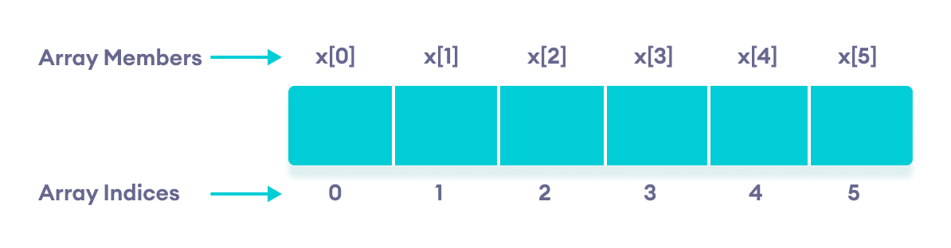Elements of an array in C++

**Question No 1 (function with parameter passed by value):**

Implement the following function in C++ called that takes in as input a number N and prints the first N number of the fibonacci sequence. Please also write the driver program for N = 10 and 15.

void fibonacciSeries(int n)

**Question No 2 (function with parameter passed by reference):**

Write a program in C++ (using function with parameter passed in by reference) for finding the character grade against marks out of 100. The character grade is determined as follows:

If the marks are more than 80 the grade is A

If the marks are more than 65 but less than 80 the grade is B

If the marks are more than 50 but less than 65 the grade is C

If the marks are less than 50 the grade is F

The function’s signature should be as follows:

void calculateGrade( int marks, char &grade)

The driver program should include a loop that lets the user repeat the grade calculation until the user enters -1.

**Question#3**

void **resverse_Array**(int arr [ ], int size), Implement the function reverse_Array. Don’t print the array. Take care of even and odd size. Only function implementation is required. Don’t declare any new array.

|  |  |  |  |  |
| --- | --- | --- | --- | --- |
| 4 | 5 | 2 | 1 | 9 |

**Reverse is**

|  |  |  |  |  |
| --- | --- | --- | --- | --- |
| 9 | 1 | 2 | 5 | 4 |